Case Study 71: Integrated University Fee and Eligibility Audit
1. Problem Statement
Combine fee payment, attendance, internal marks and examination eligibility conditions. Identify students who have outstanding requirements and report the reason for each student.
2. Objectives
Check fee clearance, attendance and internal marks.
Report every unmet condition rather than stopping at the first failure.
Classify each student as eligible or not eligible.
3. Assumptions
Fee is cleared when paid amount is at least ₹20,000.
Minimum attendance is 75%.
Minimum internal mark is 40 out of 100.
All conditions must be satisfied for examination eligibility.
4. Algorithm
Read each student's fee, attendance and internal mark.
Create an empty list of reasons.
Check each rule and add any failed condition.
If no reasons exist, mark eligible.
Display each student's status and reasons.
5. Flowchart
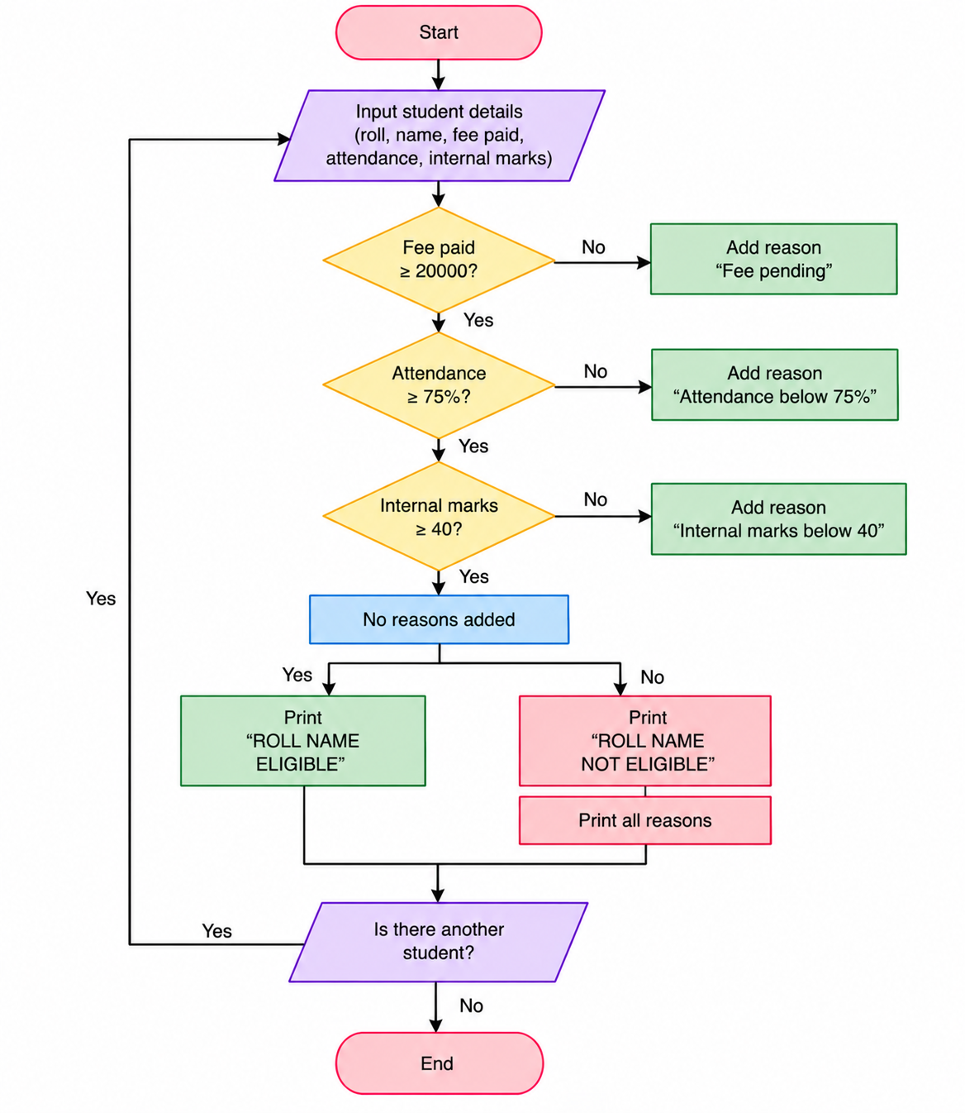
7. Pseudocode
START
Read each student's fee, attendance and internal mark.
Create an empty list of reasons.
Check each rule and add any failed condition.
If no reasons exist, mark eligible.
Display each student's status and reasons.
Display result
STOP
8. Test Cases
Input / Record | Expected Result
IT101 | Eligible; all rules satisfied
IT102 | Fee pending
IT103 | Attendance below 75%
IT104 | Internal marks below 40
8. Output Screenshot
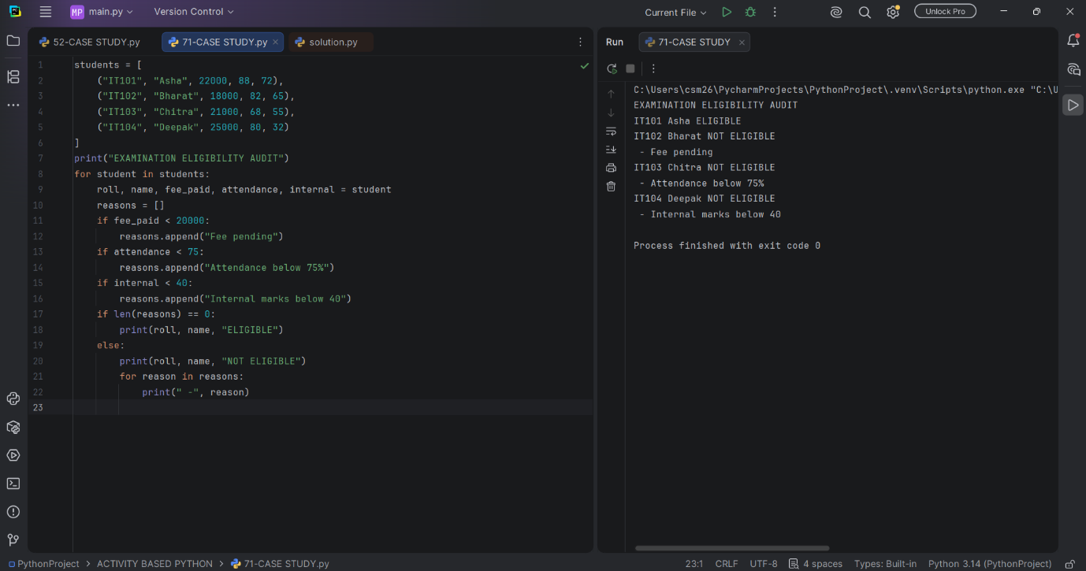
9. Conclusion
The audit checks all examination conditions and provides a reason-wise report for students who are not eligible.

